**The Power of Purpose: How Socially Responsible Companies Attract Customers and Employees**

In recent years, customers and employees have become more concerned about the social and environmental impact of the companies they patronize and work with. As a result, socially responsible companies have emerged as industry leaders, attracting customers and employees who value ethical and sustainable practices.

Those with a strong sense of purpose tend to have a clear and defined mission beyond profit-making. They understand they are responsible for contributing to society and positively impacting the world around their spheres of influence. Such companies aim to create a lasting legacy that goes beyond their financial bottom line.

Let’s explore the power of purpose, and how socially responsible companies attract and retain customers and employees.

## **Defining Corporate Social Responsibility**

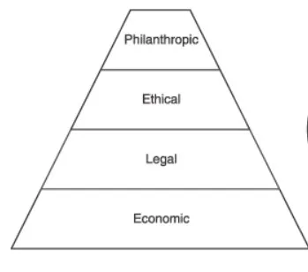

The definition of CSR can vary. However, it generally includes four main categories referred to as [Carroll's Pyramid](https://www.projectguru.in/corporate-social-responsibility-models/): philanthropic, ethical, legal, and economic responsibility.

* **Philanthropic**: dedicating a portion of earnings to charitable giving unrelated to the company's business.
* **Ethical**: treating all stakeholders fairly, from employees to customers, through responsible sourcing of materials and creating an inclusive work environment.
* **Legal:** adhering to all applicable laws and regulations and ensure their business operations do not harm society or the environment
* **Economic**: connecting financial decisions to a company's commitment to doing good.

## **What Makes a Company Socially Responsible?**

A socially responsible company considers the impact of its actions on society, the environment, and the economy. Such companies are committed to positively impacting and creating value beyond profit. Companies that possess this trait focus on four main areas:

### **Philanthropic responsibility**

Relates to a company's commitment to supporting social causes and giving back to the community. This can involve charitable donations, volunteering, or other initiatives that aim to make a positive difference in society.

### **Ethical responsibility**

Encompasses a company's adherence to ethical business practices, including the treatment of employees, suppliers, and customers. It includes fair labor practices, taking a stand against exploitation or discrimination, and ensuring that products or services are produced and marketed ethically.

### **Legal responsibility**

Socially responsible companies follow the laws, rules, and regulations that are applicable to their operations. They comply with labor laws, environmental regulations, consumer protection laws, and other relevant regulations. They make sure that their business practices do not violate the rights of any individuals, communities, or other stakeholders. They maintain transparency in their dealings, provide accurate information about their activities and performance, and avoid any fraudulent or deceptive practices. By obeying the law, socially responsible companies show their dedication to ethical behavior and their contribution to the improvement of society as a whole.

### **Economic responsibility**

Involves a company's commitment to maintaining financial stability and sustainability while contributing positively to the broader economy. This includes ethical financial practices, responsible investment, and a focus on creating jobs and supporting economic growth.

## **Why Choose CSR?**

Having a well-designed CSR program can have [positive effects](https://www.wgu.edu/blog/what-is-corporate-social-responsibility2112.html#close) on companies, employees, and consumers alike. For instance, companies can enhance their operational efficiency by reducing packaging or using less energy, thereby cutting costs while contributing to the protection of the environment.

In addition, CSR can create a competitive advantage in the market, as many consumers prefer to support companies that are known for their ethical and social responsibility. According to a [2023 consumer survey by Apiday](https://www.apiday.com/blog-posts/4-reasons-companies-should-adopt-csr-corporate-social-responsibility), 75% expressed a likelihood to begin patronizing a business that endorses a cause they believe in, while 71% desired that companies adopt positions on social issues.

A [different survey](https://www.businessnewsdaily.com/4679-corporate-social-responsibility.html) conducted by Kantar Purpose in 2020 revealed a [clear connection between a brand's perceived positive influence and its value growth](https://kantar.no/globalassets/ekspertiseomrader/merkevarebygging/purpose-2020/p2020-frokostseminar-250418.pdf). Over a 12-year period, firms regarded as highly impactful experienced a 175% increase in brand value, whereas those with a low positive effect saw just a 70% growth.

## **Practical Ways CSR Companies Attract Customers**

Now that we know what makes a company socially responsible–let us explore the practical ways these companies attract and retain customers.

### **Establishing Brand Purpose**

Companies should have a clear and compelling brand purpose that aligns with the values and aspirations of their customers. Such a purpose should be authentic and communicated clearly through all marketing channels.

### **Sustainability**

Socially responsible companies attract and retain customers by emphasizing their commitment to sustainability. This can be done through eco-friendly product lines, reducing waste and energy consumption, sourcing materials from sustainable sources, and implementing sustainable practices throughout the supply chain. By doing so, companies can appeal to consumers who value environmental sustainability and attract employees who are passionate about making a positive impact on the world.

### **Customer Engagement**

### Engage with customers directly, whether through social media or other platforms. By sharing updates on their initiatives and impact, companies can build relationships with customers and create a sense of investment in the company's mission. In addition, they can conduct cause-related marketing and customer education.

### **Transparency**

A socially responsible company is transparent about its business practices and their impact on society, the environment, and the economy. Such transparency builds customer trust and demonstrates the company's commitment to good governance. One example is to publish quarterly CSR updates and share it via social media, emails, and articles.

## **Practical Ways CSR Companies Attract Employees**

### **Employee Testimonials and Social Media**

CSR companies showcase their commitment to social and environmental issues through employee testimonials and social media channels. This can help provide a more authentic and personal perspective on the company's CSR efforts and culture, which can be attractive to job seekers.

### **Professional Development and Career Growth**

Companies that prioritize Corporate Social Responsibility (CSR) provide career advancement programs and professional development opportunities that align with their CSR initiatives. This can give job seekers the opportunity to make a positive impact while also progressing in their careers.

### **Competitive Compensation and Benefits**

Socially responsible companies offer attractive compensation and benefits packages that appeal to the most qualified individuals and demonstrate the company's commitment to its employees' well-being. These packages contain health and wellness initiatives, flexible work schedules, and opportunities for professional growth and advancement.

### **Work-Life Balance**

Aside from offering competitive compensation to employees, offering a high-priority work-life balance is a priority for most job-seekers. CSRs provide policies and programs that promote the well-being of employees in their personal and professional lives. It may involve provisions for parental leave, employee assistance programs, and more.

## **The Benefits of Being Socially Responsible**

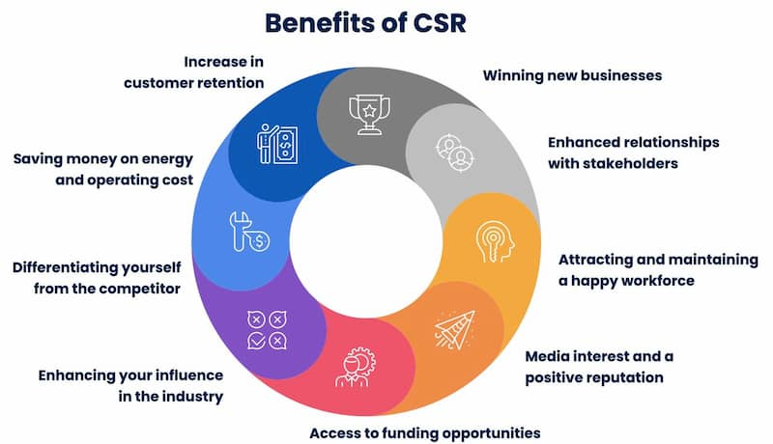

[Source](https://blog.reputationx.com/csr-and-reputation)

The benefits of being a socially responsible company are numerous and can positively impact both the company and its stakeholders.

### **Employee Retention**

Socially responsible companies tend to have higher employee loyalty and advocacy levels. When employees believe that a company shares its values and is dedicated to creating a positive impact, they are more inclined to maintain their commitment to that company and recommend it to others.

### **Competitive Advantage**

Businesses that show commitment to sustainability, social responsibility, and good governance can gain a competitive edge over their less socially accountable competitors.

### **Improved Reputation**

Socially responsible companies often have a better reputation than their less socially accountable counterparts. When a company is transparent about its business practices and their impact on society, the environment, and the economy, it can build trust with its stakeholders and enhance its reputation.

### **Reduced Risk**

Socially responsible companies often face fewer legal, regulatory, and reputational risks. Moreover, by investing in sustainability, social responsibility, and good governance, a company can reduce the likelihood of negative impacts on society, the environment, and the economy.

It’s important to note that when a company touts their corporate social responsibility (CSR) initiatives but fail to live up to them, it can have significant negative consequences. Customers and stakeholders may view the company as disingenuous or even deceptive, which can lead to a loss of trust, reputation damage, and a decline in sales. If the company's CSR initiatives are found to be misleading or inaccurate, it may face legal and regulatory consequences, which can result in financial penalties, fines, and legal fees. Employees may become disillusioned with the company's leadership and culture, which can lead to low morale, decreased productivity, and increased turnover.

## **The Bottom Line**

The power of purpose is vital to a socially responsible company. By aligning its goals with its customers' and employees' values and aspirations, a socially responsible company can attract and retain top talent, build strong relationships with its stakeholders, and positively impact society, the environment, and the economy.

Practical ways for a socially responsible company to attract customers and employees include:

* Having a clear brand purpose.
* Demonstrating a commitment to sustainability and social responsibility.
* Being transparent and engaging with stakeholders.
* Promoting diversity and inclusion.
* Offering competitive compensation and benefits packages and work-life balance policies.

By implementing these strategies, socially responsible companies can distinguish themselves from their competitors and become industry leaders.